

INSTITUTO POLITECNICO NACIONAL

ESCUELA SUPERIOR DE CÓMPUTO (ESCOM)

ANÁLISIS DE ALGORITMOS

NOMBRE DEL ALUMNO:

* SANTOS MÉNDEZ ULISES JESÚS

EJERCICIO 13:

* Ejercicios sobre Dijkstra, Prim y Kruskal.

FECHA DE ENTREGA:

* 16/06/2022

GRUPO:

* 3CM14



**Ejercicio 01:**

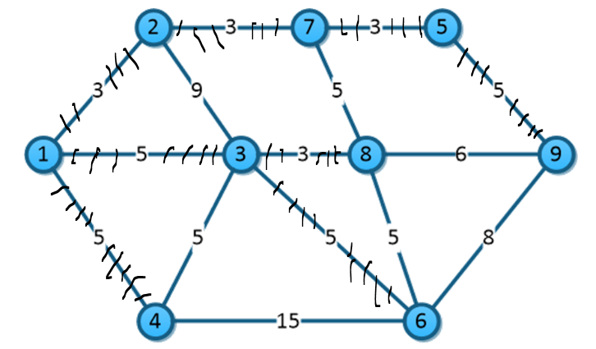

|  |  |  |
| --- | --- | --- |
| 1,2 | 3 | ✓ |
| 2,7 | 3 | ✓ |
| 7,5 | 3 | ✓ |
| 3,8 | 3 | ✓ |
| 5,9 | 5 | ✓ |
| 1,3 | 5 | ✓ |
| 7,8 | 5 | 🗶 |
| 1,4 | 5 | ✓ |
| 3,4 | 5 | 🗶 |
| 3,6 | 5 | ✓ |
| 8,6 | 5 | 🗶 |
| 8,9 | 6 | 🗶 |
| 6,9 | 8 | 🗶 |
| 2,3 | 9 | 🗶 |
| 4,6 | 15 | 🗶 |

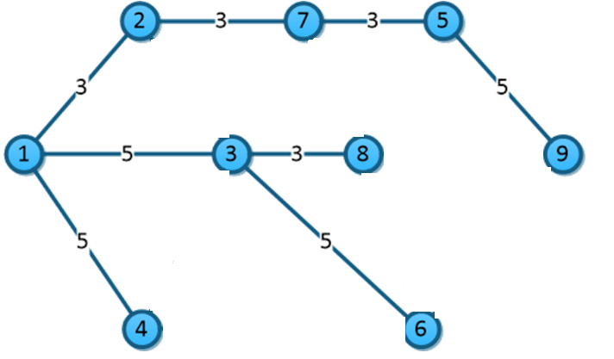 MST= 12+20+= 32

**Ejercicio 02:**

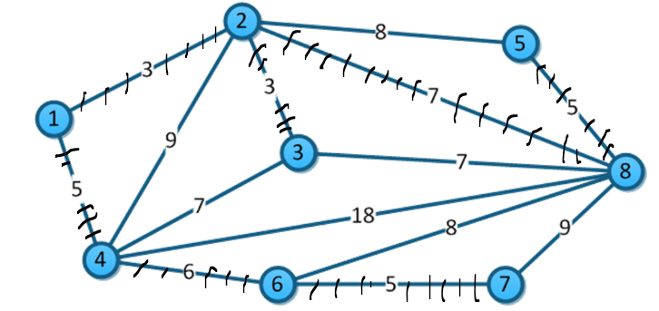

|  |  |  |
| --- | --- | --- |
| 1,2 | 3 | ✓ |
| 2,3 | 3 | ✓ |
| 5,8 | 5 | ✓ |
| 1,4 | 5 | ✓ |
| 6,7 | 5 | ✓ |
| 4,6 | 6 | ✓ |
| 2,8 | 7 | ✓ |
| 3,4 | 7 | 🗶 |
| 3.8 | 7 | 🗶 |
| 2,5 | 8 | 🗶 |
| 6,8 | 8 | 🗶 |
| 2,4 | 9 | 🗶 |
| 7,8 | 9 | 🗶 |
| 4,8 | 18 | 🗶 |

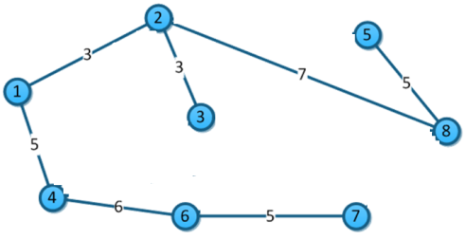MST= 6 +15+13 = 34

**Ejercicio 03:**

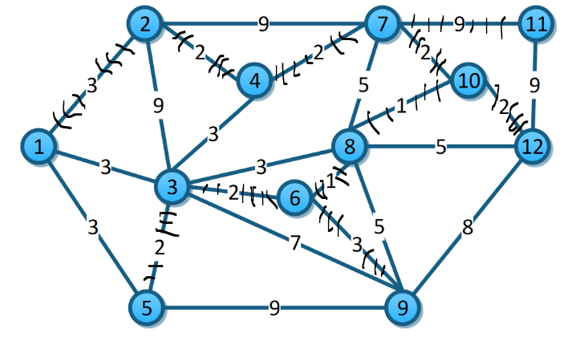

|  |  |  |
| --- | --- | --- |
| 8,10 | 1 | ✓ |
| 6,8 | 1 | ✓ |
| 7,10 | 2 | ✓ |
| 10,12 | 2 | ✓ |
| 4,7 | 2 | ✓ |
| 2,4 | 2 | ✓ |
| 3,6 | 2 | ✓ |
| 3,5 | 2 | ✓ |
| 1,2 | 3 | ✓ |
| 1,3 | 3 | 🗶 |
| 3,4 | 3 | 🗶 |
| 3,8 | 3 | 🗶 |
| 1,5 | 3 | 🗶 |
| 6,9 | 3 | ✓ |
| 8,12 | 5 | 🗶 |
| 7,8 | 5 | 🗶 |
| 8,9 | 5 | 🗶 |
| 3,9 | 7 | 🗶 |
| 9,12 | 8 | 🗶 |
| 2,7 | 9 | 🗶 |
| 7,11 | 9 | ✓ |
| 11,12 | 9 | 🗶 |
| 2,3 | 9 | 🗶 |
| 5,9 | 9 | 🗶 |

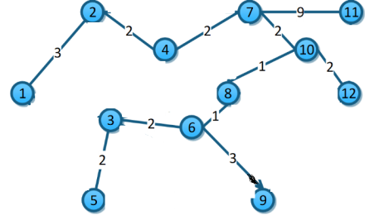 MST= 2+12+6+9 = 29

**Ejercicio 04:**

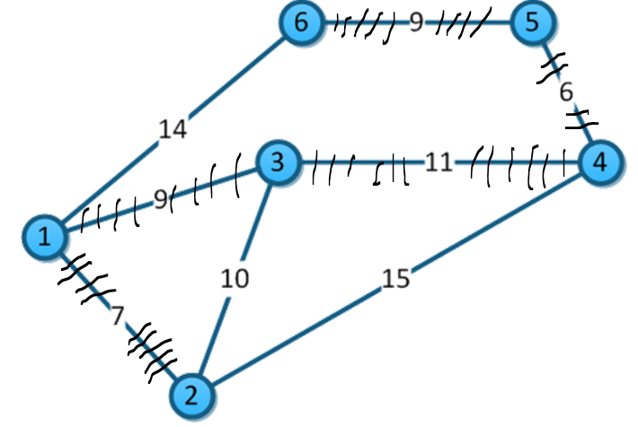

|  |  |  |
| --- | --- | --- |
| 4,5 | 6 | ✓ |
| 1,2 | 7 | ✓ |
| 1,3 | 9 | ✓ |
| 5,6 | 9 | ✓ |
| 2,3 | 10 | 🗶 |
| 3,4 | 11 | ✓ |
| 1,6 | 14 | 🗶 |
| 2,4 | 15 | 🗶 |

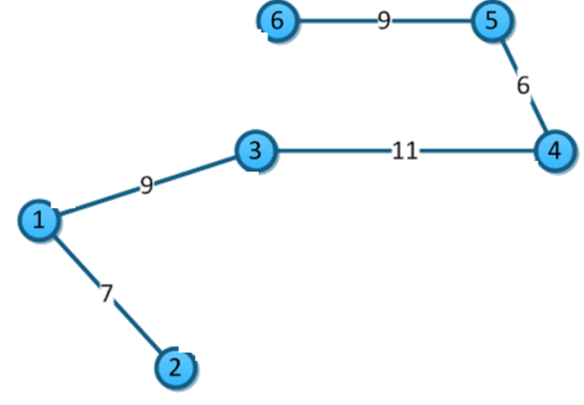 MST=6+7+9+9+11= 42

**Ejercicio 05:**

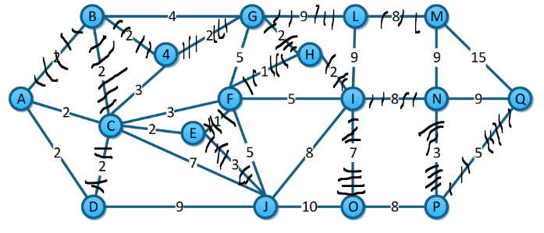

|  |  |  |
| --- | --- | --- |
| F,H | 1 | ✓ |
| E,F | 1 | ✓ |
| B,4 | 2 | ✓ |
| 4,G | 2 | ✓ |
| G,H | 2 | ✓ |
| H,I | 2 | ✓ |
| A,B | 2 | ✓ |
| B,C | 2 | ✓ |
| A,C | 2 | 🗶 |
| C,E | 2 | 🗶 |
| C,D | 2 | ✓ |
| 4,C | 3 | 🗶 |
| C,F | 3 | 🗶 |
| N,P | 3 | ✓ |
| E,J | 3 | ✓ |
| B,G | 4 | 🗶 |
| F,G | 5 | 🗶 |
| F,I | 5 | 🗶 |
| F,J | 5 | 🗶 |
| P,Q | 5 | ✓ |
| I,O | 7 | ✓ |
| C,J | 7 | 🗶 |
| L,M | 8 | ✓ |
| I,J | 8 | 🗶 |
| I,N | 8 | ✓ |
| O,P | 8 | 🗶 |
| G,L | 9 | ✓ |
| L,I | 9 | 🗶 |
| M,N | 9 | 🗶 |
| N,Q | 9 | 🗶 |
| D,J | 9 | 🗶 |
| J,O | 10 | 🗶 |
| M,Q | 15 | 🗶 |

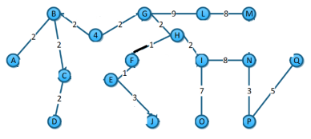 MST=2+14+6+5+7+8+8+9 = 59